**LAB REPORT NO 10**



Submitted by:  **Muhammad Ali**

Registration No: - **19PWCSE1801**

Class Section: A

“On my honor, as student of University of Engineering and Technology, I have neither given nor received unauthorized assistance on this academic work.”

Submitted to:

**Engr. Durr-e-Nayab**

Data:(12,08,2021)

Department of Computer Systems Engineering

University of Engineering and Technology, Peshawar

**Objectives: -**

* Fourier series of continues time signal.
* To analysis Fourier series periodic signal
* To learn linear combination.

**Task no 1: -**

clc

clear all

close all

t = -3:0.01:3;

x0 = 1;

x1 = (1/8)*exp(j*(-1)*2*pi*t)+(1/4)*exp(j*(1)*2*pi*t);

y1 = x0 + x1;

x2 = (1/4)*exp(j*(-2)*2*pi*t)+(1/2)*exp(j*(2)*2*pi*t);

y2 = y1 + x2;

x3 = (1/5)*exp(j*(-3)*2*pi*t)+(1/3)*exp(j*(3)*2*pi*t);

x = x0 + x1 + x2 + x3;

figure;

subplot(3,2,1);

plot(t,x1);

axis([-3 3 -2 2]);

title('x1(t)');

subplot(3,2,2);

plot(t,y1);

title('x0(t)+x1(t)');

subplot(3,2,3);

plot(t,x2);

axis([-3 3 -2 2]);

title('x2(t)');

subplot(3,2,4);

plot(t,y2);

title('x0(t)+x1(t)+x2(t)');

subplot(3,2,5);

plot(t,x3);

title('x3(t)');

subplot(3,2,6);

plot(t,x);

title('x(t)=x0(t)+x1(t)+x2(t)+x3(t)');

**Discussion: -**

We observe that change in ak’s of a signal is still symmetric about origin.

**Output: -**

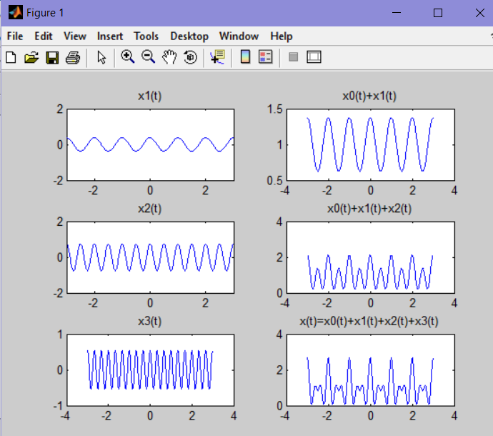

**Task no 2: -**

clc

clear all

close all

t = -3:0.1:3;

a0 = 1;

a2 =exp(j*2*pi/4*t)+exp(j*(2)*pi/4*t);

y1 = a0 + a2;

a3 =exp(j*(-4)*pi/4*t)+exp(j*(4)*pi/4*t);

x = a0 + a2 + a3;

figure;

subplot(3,2,1);

stem(t,a2);

axis([-3 3 -2 2]);

title('x2(t)');

subplot(3,2,2);

stem(t,y1);

title('y1(t)');

subplot(3,2,3);

stem(t,a3);

title('x3(t)');

subplot(3,2,4);

stem(t,x);

title('x(t)=x0(t)+x2(t)+x3(t)');

**Output: -**

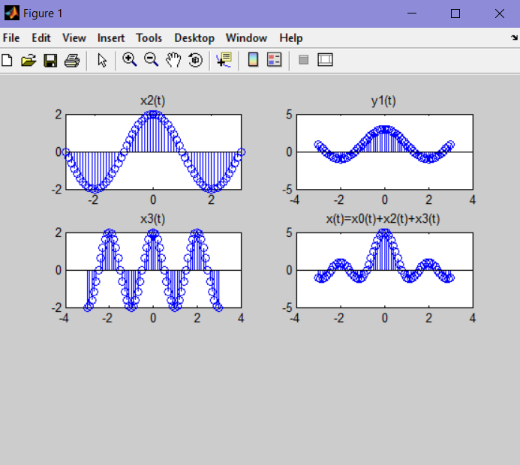

**Task no 3: -**

t = -1.5:0.005:1.5; %duration of square wave

xcos = cos(2*pi*t); %cosine wave of 1 Hz

xpsqw = xcos>0; %thresholding cosine wave using relational operator

figure

plot(t,xpsqw,'lineWidth',2);

xlabel('t');

ylabel('x(t)');

title('Periodic Square Wave (T=1)');

axis([-1.5 1.5 -0.1 1.1]);

grid;

**Output: -**

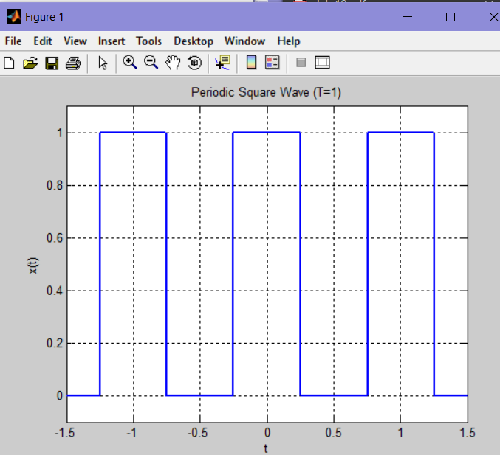

**Task no 4: -**

clc

clear all

close all

k = -15:15;

T = 1;

T1 = 1/16; %duty cycle of square wave

ak1 = sin(k*2*pi*(T1/T))./(k*pi);

ak1(16) = 2*T1/T;

figure;

subplot(3,1,1);

stem(k,ak1,'filled');

ylabel('ak');

title('FS Coefficients for Periodic Square Wave (T=1, T1=1/16)');

T1 = 1/32;

ak2 = sin(k*2*pi*(T1/T))./(k*pi);

ak2(16) = 2*T1/T; % Manual correction for a0 ?> ak2(16)

subplot(3,1,2);

stem(k,ak2,'filled');

ylabel('ak');

title('FS Coefficients for Periodic Square Wave... (T=1, T1=1/32)');

T1 = 1/64;

ak3 = sin(k*2*pi*(T1/T))./(k*pi);

ak3(16) = 2*T1/T;

subplot(3,1,3);

stem(k,ak3,'filled');

xlabel('k');

ylabel('ak');

title('FS Coefficients for Periodic Square Wave (T=1, T1=1/64)')

**discussion: -**

By reducing duty cycle T1 from 1/4 to 1/16 the time period of a signal increases.

**Output: -**

